How to run and trace a program in Eclipse

A. You first need to install a new version of java. Download and install:

Java SE Development Kit 6u23

From:

http://www.oracle.com/technetwork/java/javase/downloads/index.html

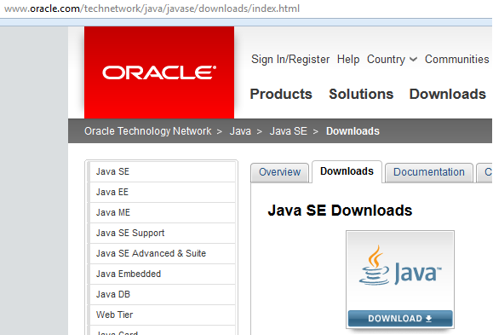

Click on the following icon:

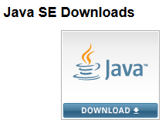

Scroll down click on the radio button to accept: Java SE Development Kit 8u121.
The name of the installer for a 64-bit PC (not Mac) is: jdk-8u121-windows-x64.exe.

After you installed java you should be able to see two folders: jdk1.8.0_121 and jre1.8.0_121 in C:\Program Files\Java.

B. Download Eclipse from:

http://www.eclipse.org/downloads/download.php?file=/technology/epp/downloads/release/neon/1/eclipse-jee-neon-1-win32-x86_64.zip

The name of the file is: eclipse-jee-neon-1-win32-x86_64.zip.

Unzip the file (I unzipped it into C:\Program Files), and put its short-cut icon on your desktop.

Make a folder on your C drive say “Projects”. Now in “Projects” make a folder called “Project1”. In the following I am making a project file.
Note: To read each of following pictures more clearly click on the lower right corner and drag it.

Double-click on the eclipse icon on the desktop. Click on Browse and find the folder Project1. You see the following figure:

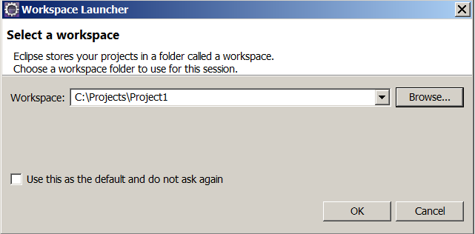

Click OK to get:

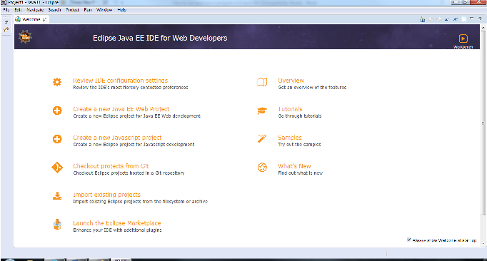

On the upper left corner click on to close the Welcome to Eclipse to get (You can bring this window back from the help icon):

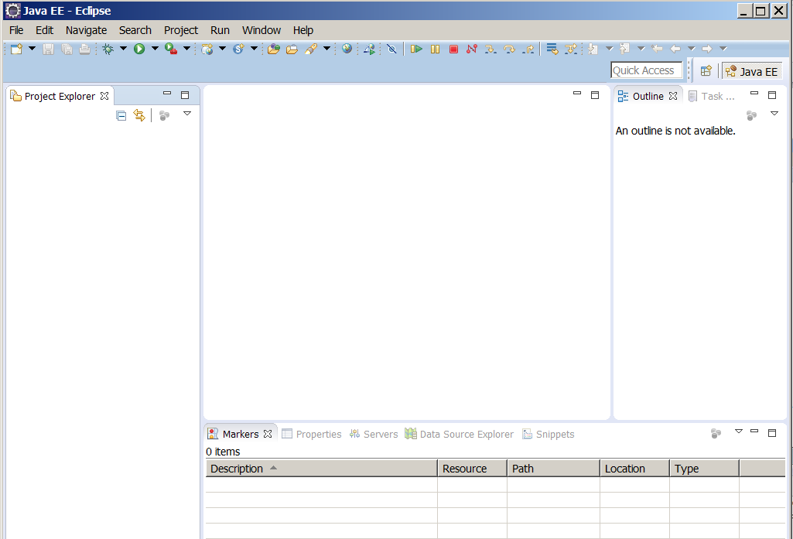

4. We now create a project file. Click on: File → New → Project → Java Project to display the New Project wizard:

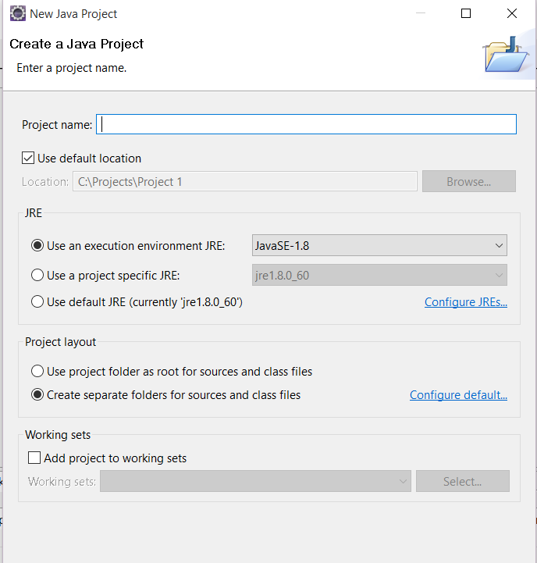

Type myProject1 (no space between my, Project, and 1) for the Project name field:

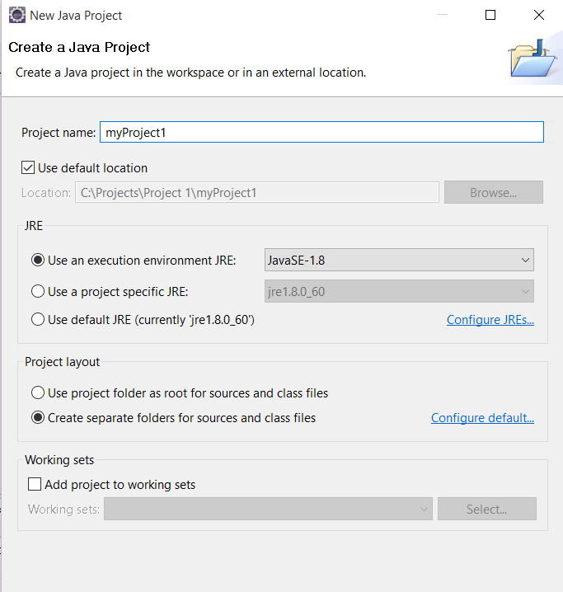

Click Finish and click on: Yes to see:

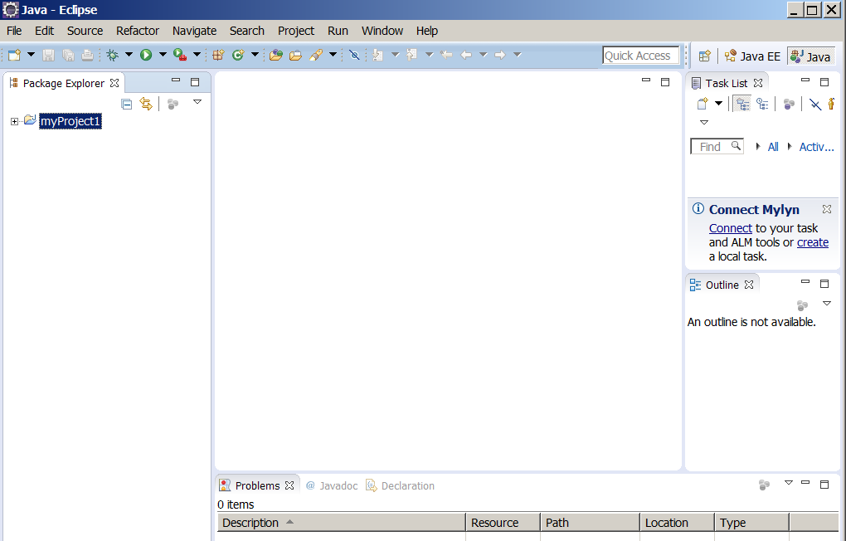

We now create the first program. On the menu bar click on File → New → Class:
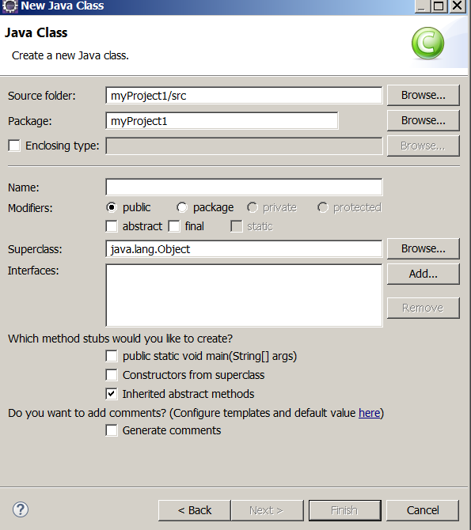

Delete the content of the window labeled: Package and in the window labeled Name enter Main:
Note: Always name your main class Main. The name of a class must start with an uppercase letter. Click on Finish button to get:

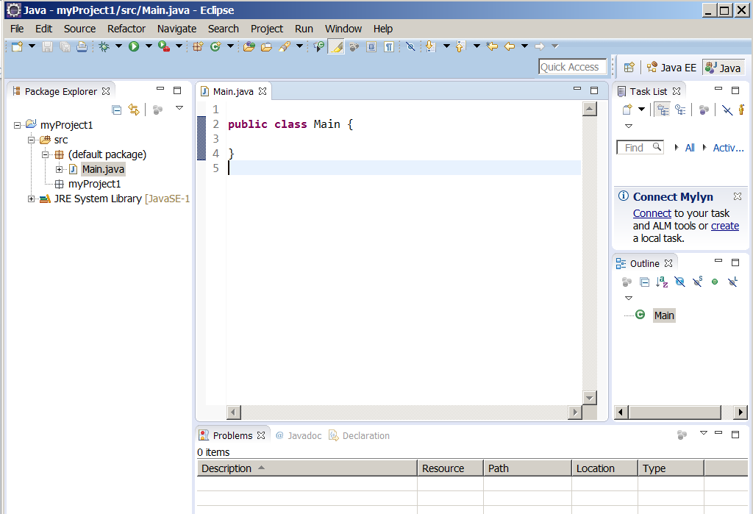

Replace the content of the editor by the following class:

public class Main {
public static void main(String[] args){
System.out.println("Hello World");
}
}

You do not need to compile the program. As you type the program Eclipse compiles it. When a java program is compiled it creates a file with extension class. The Eclipse compiler translates every java file to a class file. The content of Main.class is called byte codes. The java interpreter executes this file and displays output of your program. In case you have errors in your program Eclipse dynamically checks the syntax errors. To run the program on the menu bar click on Run → Run to see:

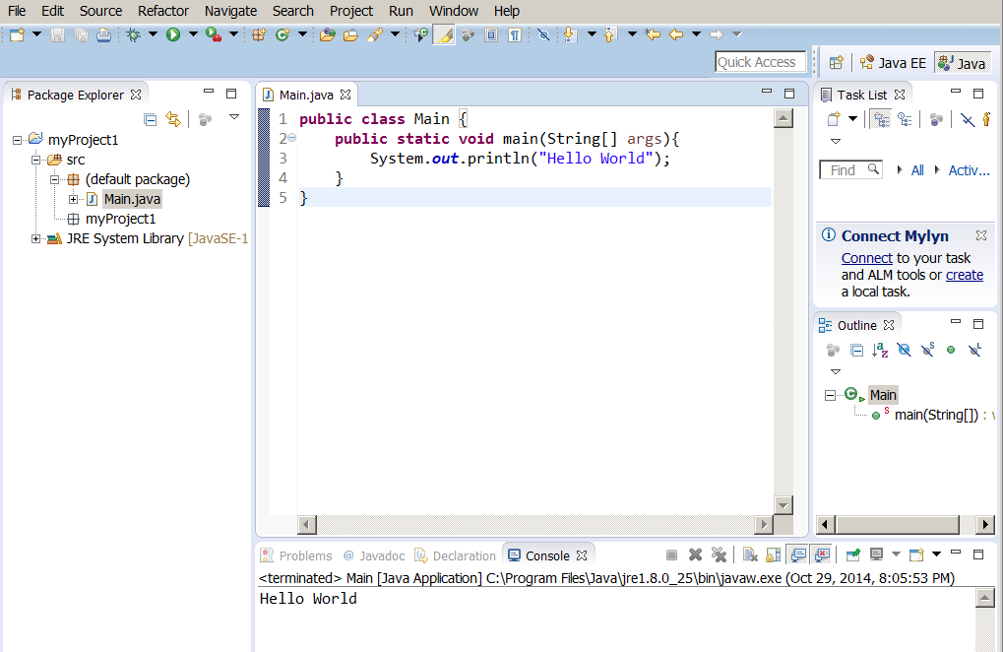

Note: Once you run the program you do not need to run it this way. You can click on on the menu bar.

Click on File → Exit to exit from eclipse (Or simply close the window).

As you are going through this tutorial, your program may consist of several classes (java files). In the following subject we first make a program with two classes and then debug it.

A program with more than one class Eclipse

Create a second folder name Project2 in the folder Projects. Click on the icon Eclipse to activate it.

Make a project folder named myProject2. Make a class named: Main as you did above:

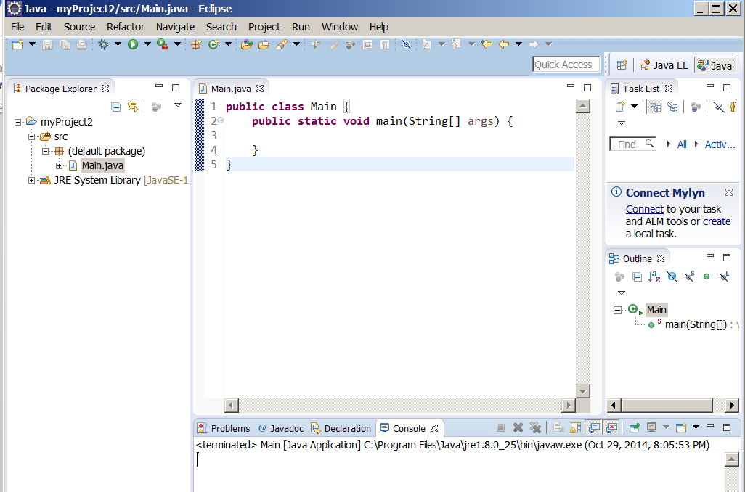

We now create the second class. On the upper left corner click on File → New→ Class. Type Second for the name of the class (No package). Click on Finish to get:

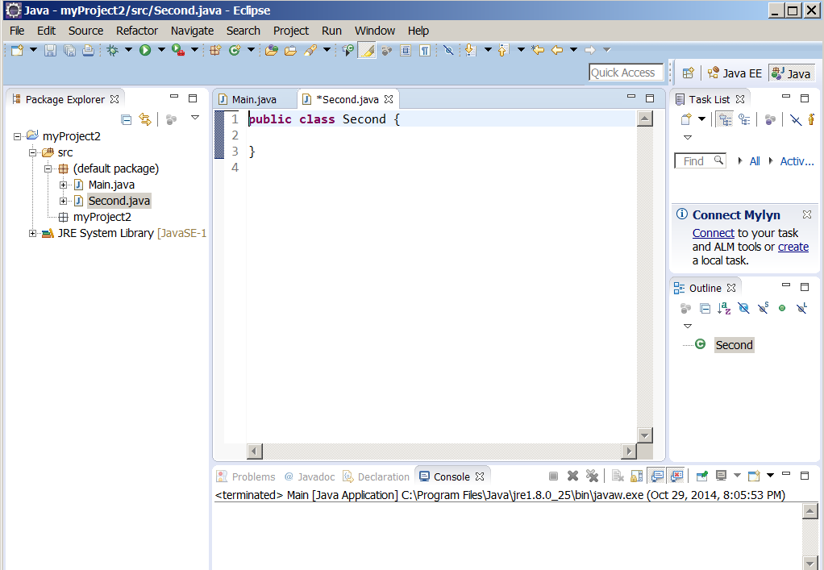

You now have two empty classes. I am going to make a method for the second class with some code that you will learn them later. The purpose of this tutorial is to learn how to make a program and how to trace it. You will learn java from my Java tutorial.
Note: Its is customary to type the name of a class starting with upper case letter and type the name of a method (like main) in lower case letters.

Replace the content of the second class by the following:

import java.util.Scanner;

public class Second {
public void sum(){
int m = 0, n;

Scanner key = new Scanner(System.in);
System.out.println("Enter a positive number: ");
n = key.nextInt();
for(int i = 1; i <= n; i++)
m = m + i;
System.out.println("The sum of 1 + 2 + .... + " + n + " is: " + m);
}
}

Your editor should look like:

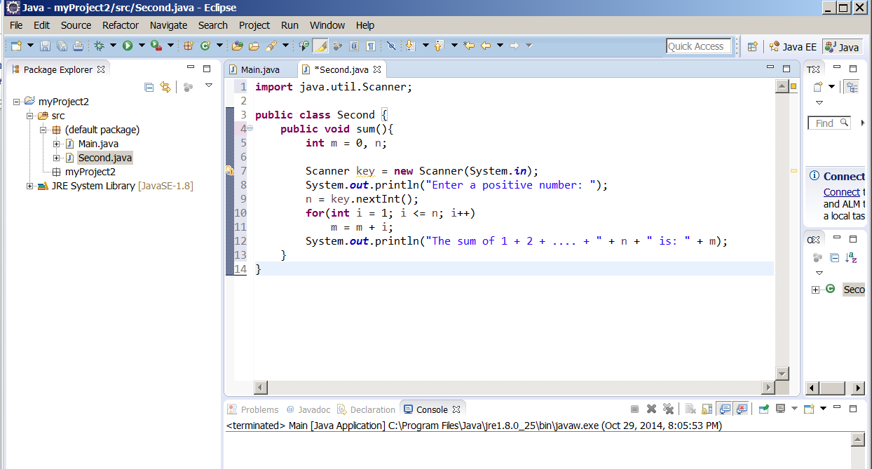

Note: Indentation is important. We use tab key for indentation. As your classes get bigger and bigger indentation of the lines makes your program:

- More readable.
- Easier to trace and debug.

Therefore from the beginning indent all lines of your classes. If you do not indent your classes from the beginning changing you habit to impose indentation is not easy.

Click on main on the menu bar to bring the class Main.java on the screen. Replace the content of the Main class with:

public class Main {
public static void main(String[] args) {
Second x = new Second();
x.sum();
}
}

7. Like the first project run this project.
The console icon in the lower window is high lighted and the message Enter a positive number: shows up. Enter a number (like 5) and hit Enter key. The output of the program shows up.
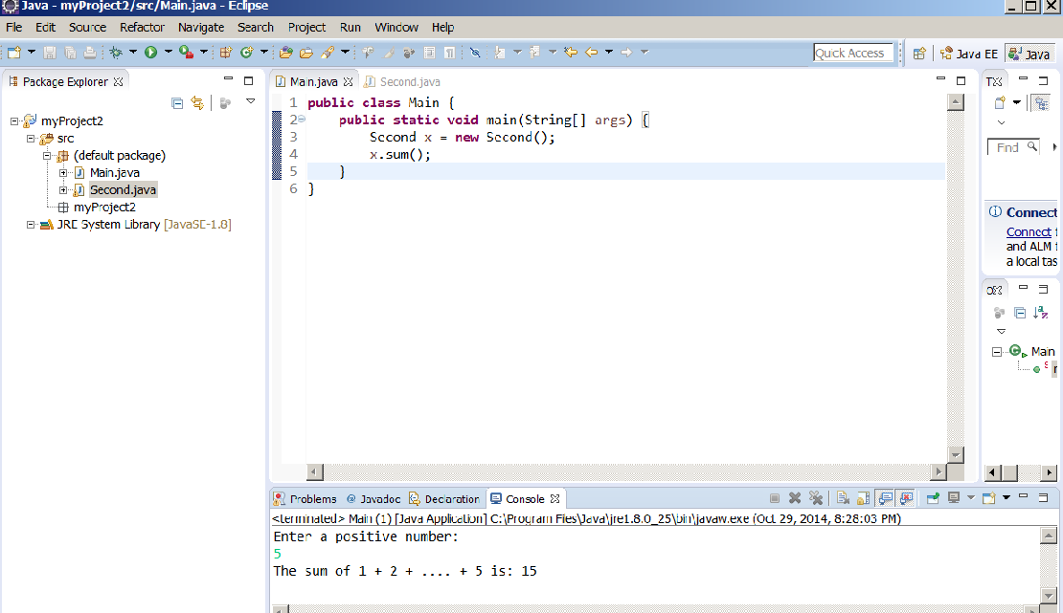

Tracing a java program

There are times you make a program, run it but you do not get the desired answer. In this situation you need to trace your program and look at the value of your variable. First we trace the program instruction by instruction.

Click on Window → Open Perspective → Debug to get:

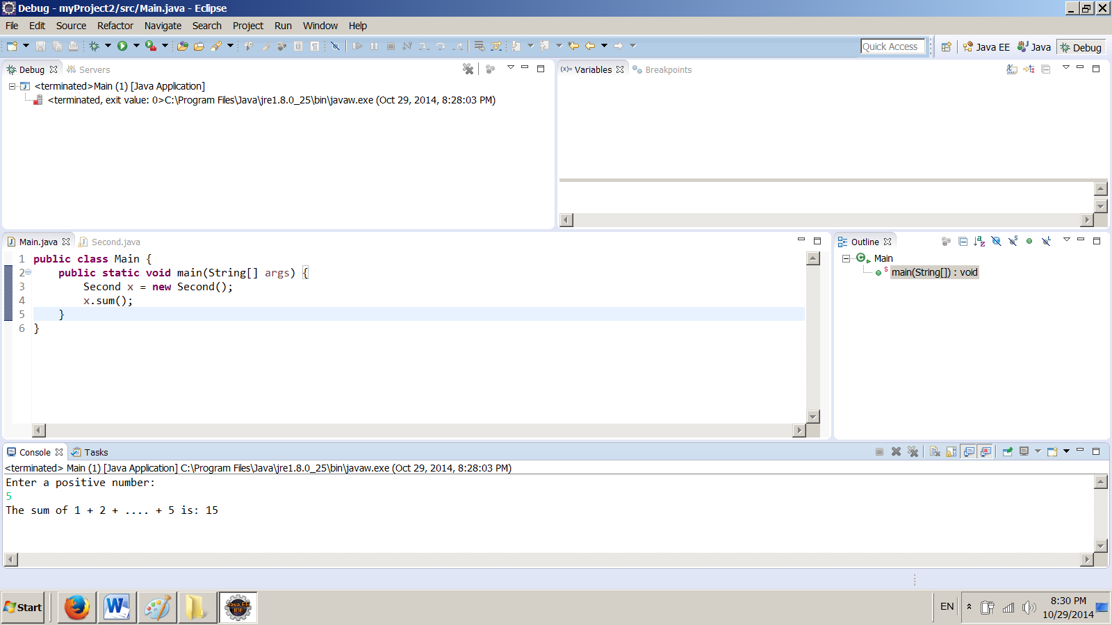

Temporary make this picture bigger to see the purpose of each window.

In the class Main on the margin of the first instruction right-click:

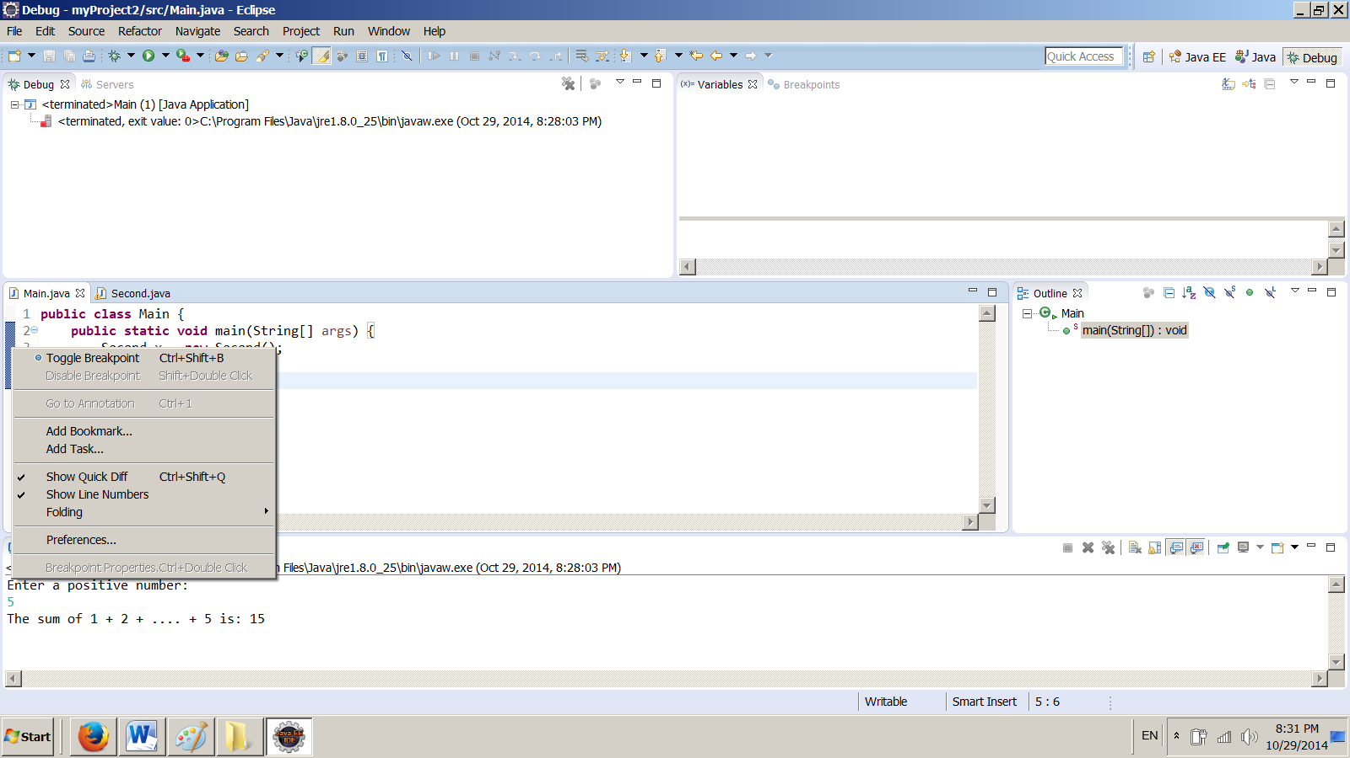

Select Toggle Breakpoint. You should see a small circle on the margin:

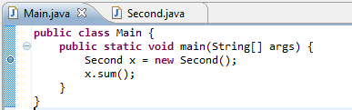

On the menu bar click on Run (not on ) to see the following window. Click on Debug As to see:

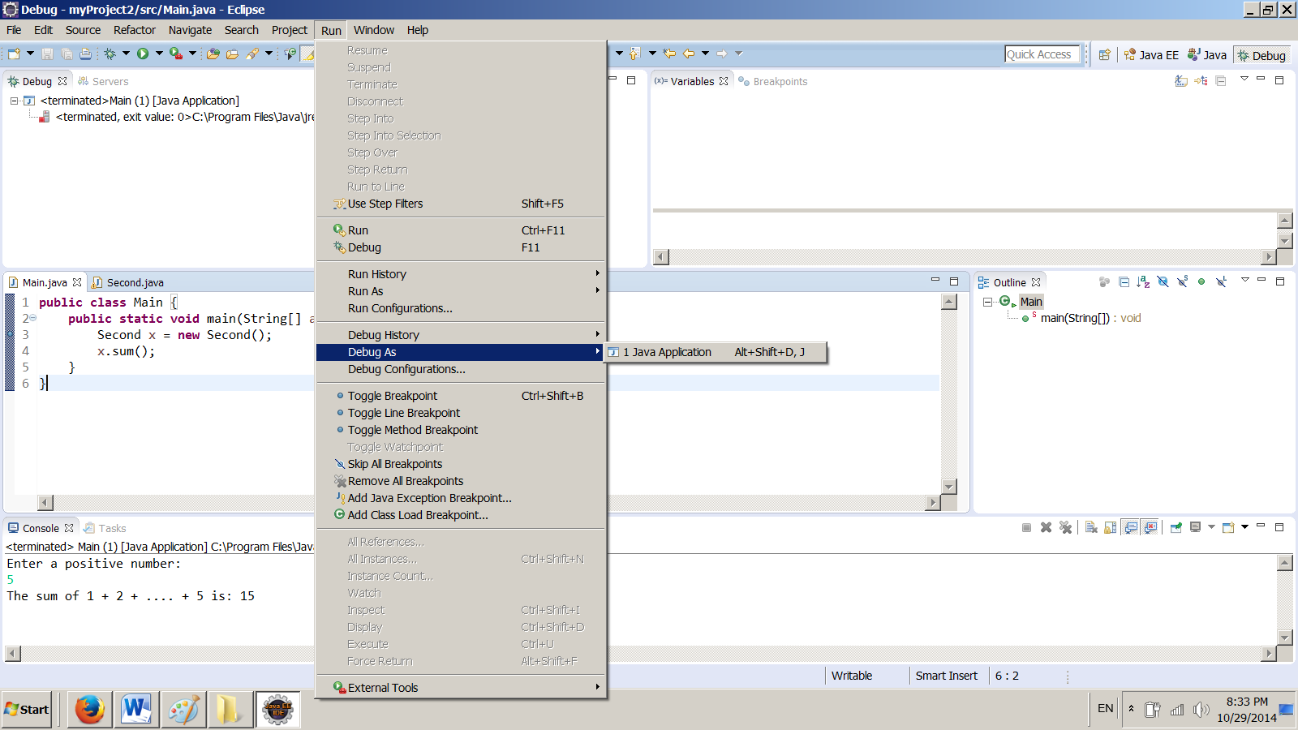

Let us take look at some of the items in this window:

Resume resumes the execution of a paused program. Later simply hit F8 for this.
Suspend temporarily stops execution of a program.
Terminate ends the current debugging session. Later simply hit Crl+F2 for this.
Step Into executes a single statement or steps into a method. Later simply hit F5 for this.
Step Over executes a single statement. If the statement contains a call to a method, the entire method is executed without stepping through it. Later simply hit F6 for this.
Step Return executes all the statements in the current method and returns to its caller.
Run to Line runs the program, starting from the current execution point, and pauses on the first break point on the line.
Note the there is a highlight on line: 3 of the Main class. This means the system executed the program up to this line.

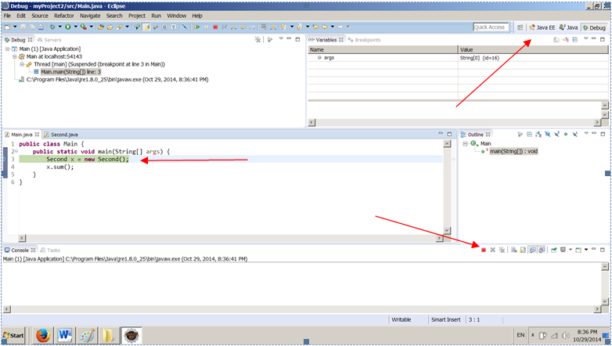

Click on the red dot. Click on upper right corner on: Java EE to see:

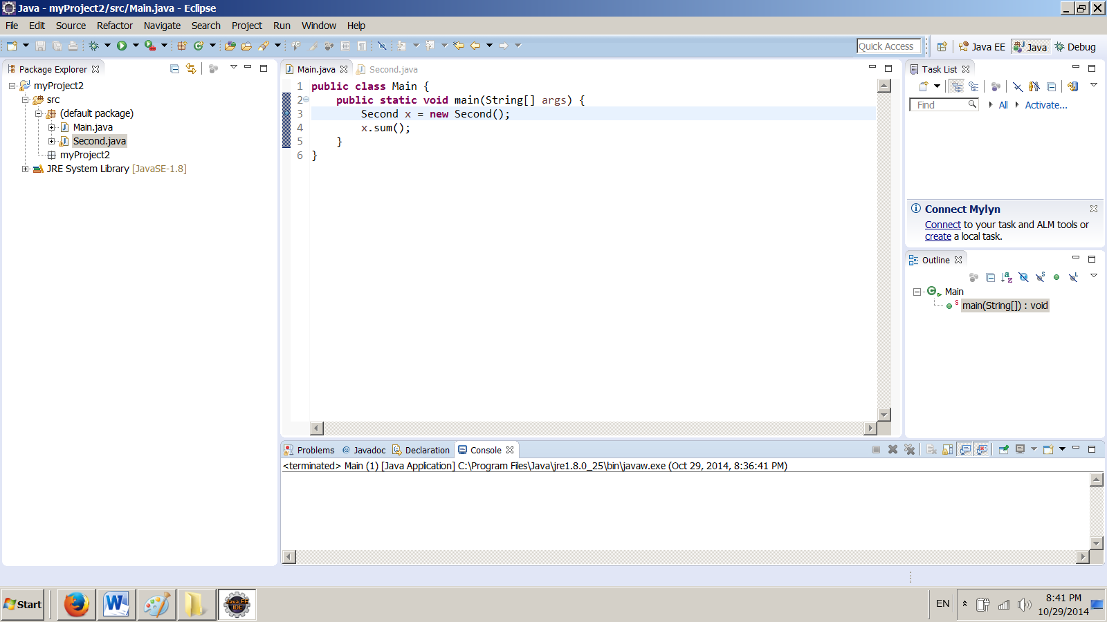

Hit F11, F6, F5, F5, F6, and F6 to get to the following situation:

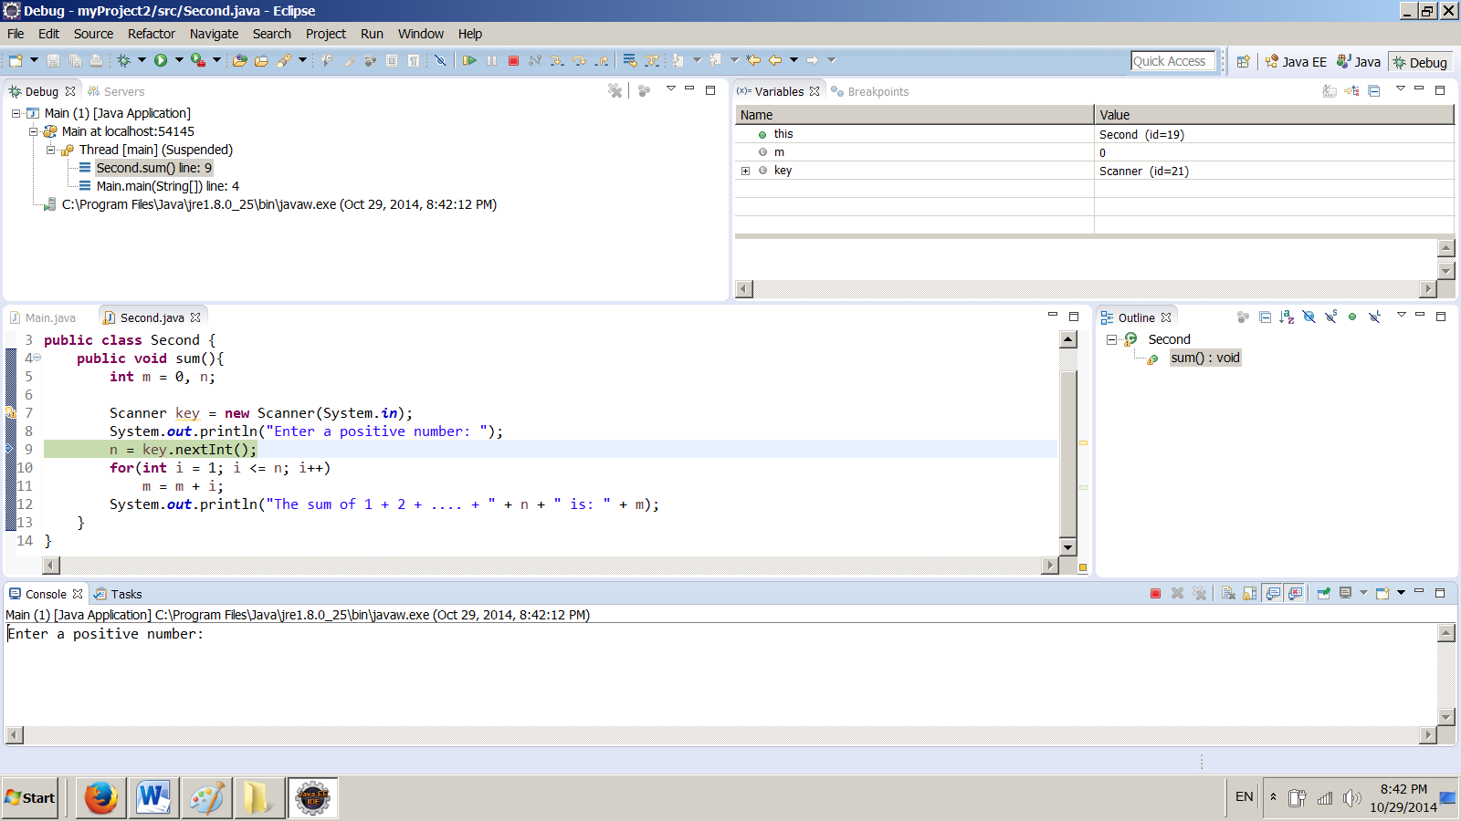

Note: On the built-in Java classes and method calls like:

Scanner key = new Scanner(System.in);
or
System.out.println("Enter a positive number: ");

Press F6 to Step Over. After all you don’t want to look the code of these java classes and methods.

Once the high light is over:

n = key.nextInt();

Hit F6 and enter a number (like 5) in the lower window and hit enter.

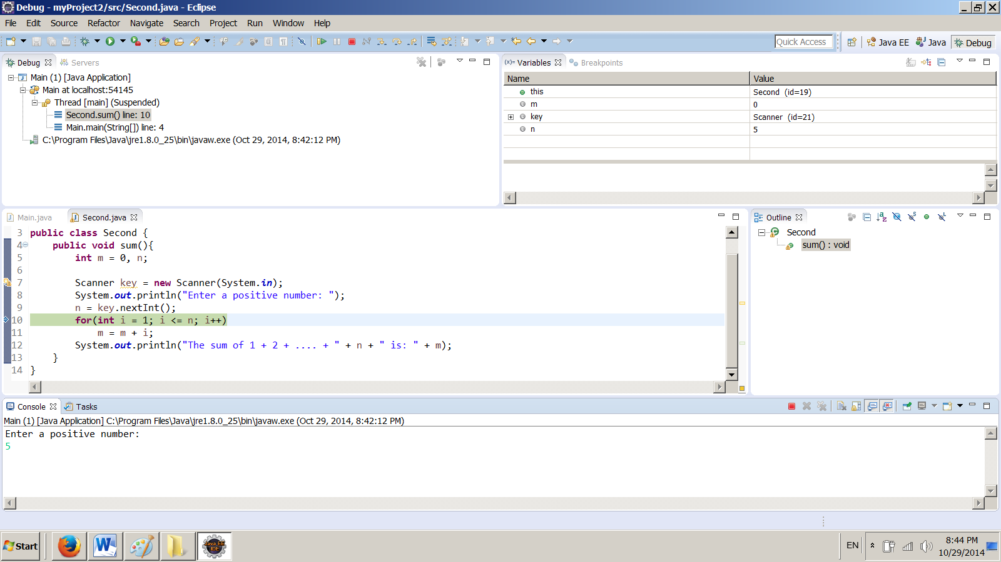

Note: Enlarge this picture to see the lines more clearly.
Look at the Variables window to see the value of the variables. The second and fourth lines are understandable. At this stage the value of the variables m and n are 0 and 5 respectively. Keep hitting F5 and watch the value of the variables. When the highlight is on the last statement: System.out.println("The sum of 1 + 2 + .... + " + n + " is: " + m);
The window of the variables are:

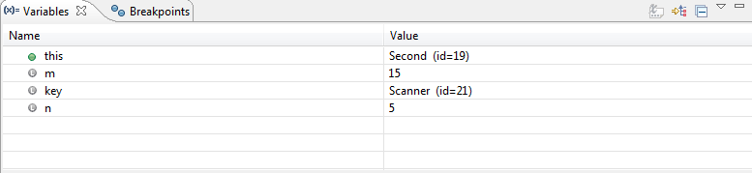

Note: the numbers for id= 19 and/or id=21 could be different on your computer. But the values for m and n must be 0 and 5 respectively

Eventually the execution of program is terminated.

Note: If you like to terminate the program at any stage click on the small red-icon on the menu bar.

You see one application of a breakpoint. Another application of breakpoint is for the time you are sure part of the program is correct. In this situation make a breakpoint after this part.
Note: To remove a breakpoint point to it, right-click, and select Toggle Breakpoint.
Click on Main.java icon to activate the Main class and remove its break point.

In class Second make a break point on the margin of the instruction:
System.out.println("The sum of 1 + 2 + .... + " + n + " is: " + m); the window for Second.java look like:

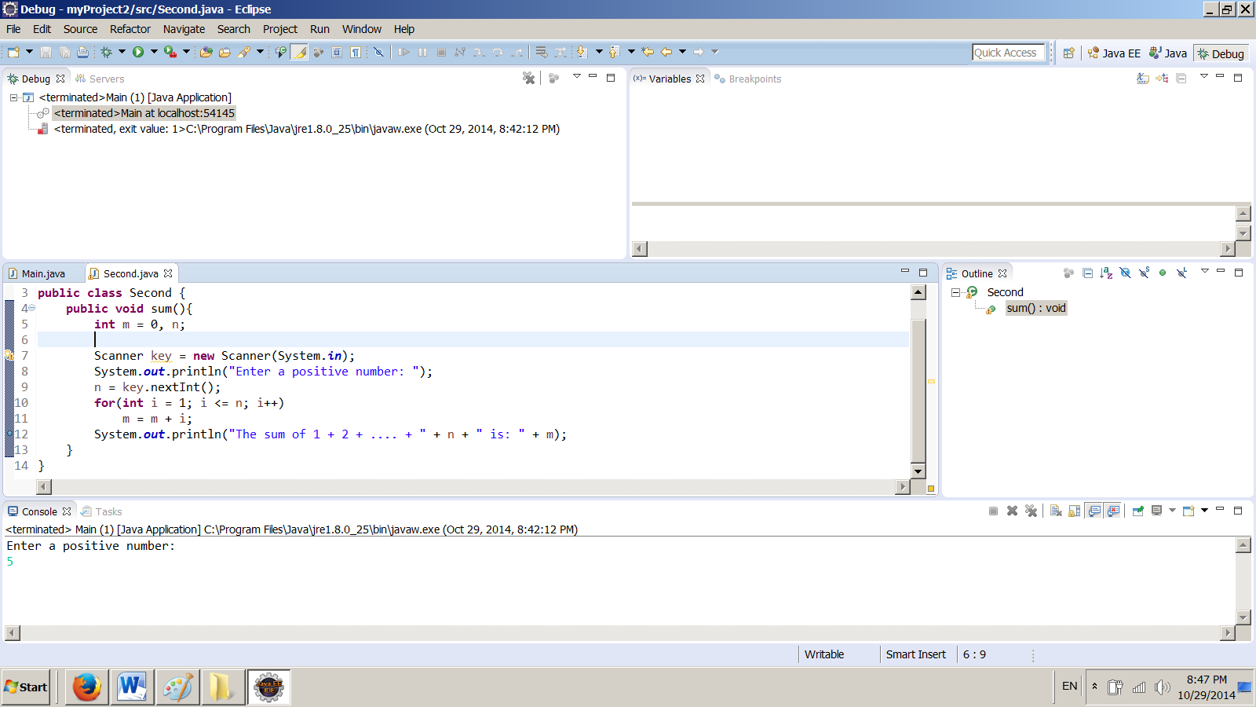

On the menu bar click on Run and click on Debug icon (or hit F11) and enter 5 to see:

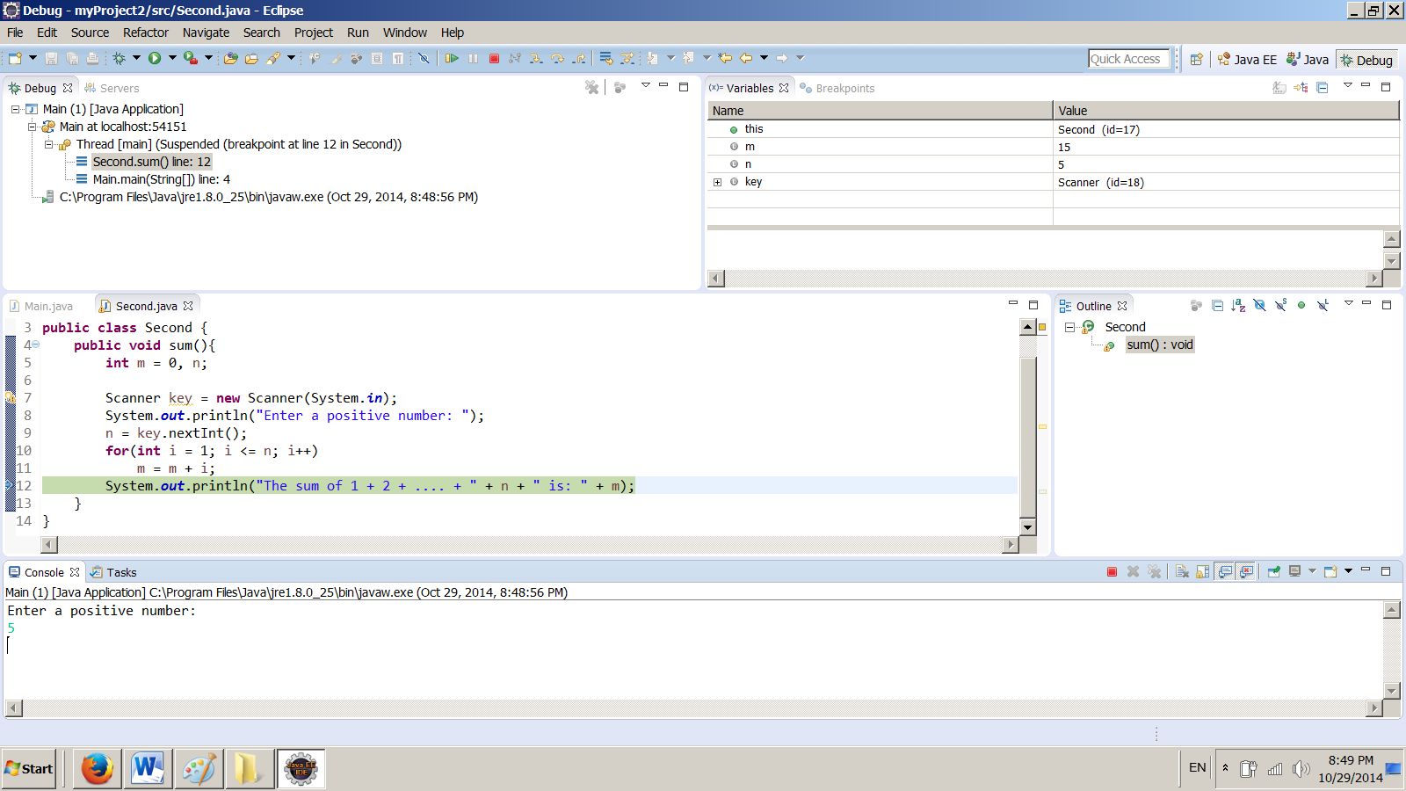

Note that the execution of the program stopped on the breakpoint. See the value of the variables.
On the menu bar click on the small red icon to terminate the execution of the program.

